**AL-2001**

**Programming for AI**

**Lab # 1**

* **Intro & Installation of Software**

**Installing Jupyter Notebook on Windows**

Jupyter Notebook can be installed by using either of the ways described below:

**Using Anaconda:**

Install Python and Jupyter using the Anaconda Distribution, which includes Python, the Jupyter Notebook, and other commonly used packages for scientific computing and data science. To install Anaconda, go through [How to install Anaconda on windows?](https://www.geeksforgeeks.org/how-to-install-anaconda-on-windows/) and follow the instructions provided.

**Installing Jupyter Notebook using Anaconda**

Anaconda is an open-source software that contains Jupyter, spyder, etc that are used for large data processing, data analytics, heavy scientific computing. Anaconda works for R and python programming language. Spyder(sub-application of Anaconda) is used for python. Opencv for python will work in spyder. Package versions are managed by the package management system called conda. To install Jupyter using Anaconda, just go through the following instructions:

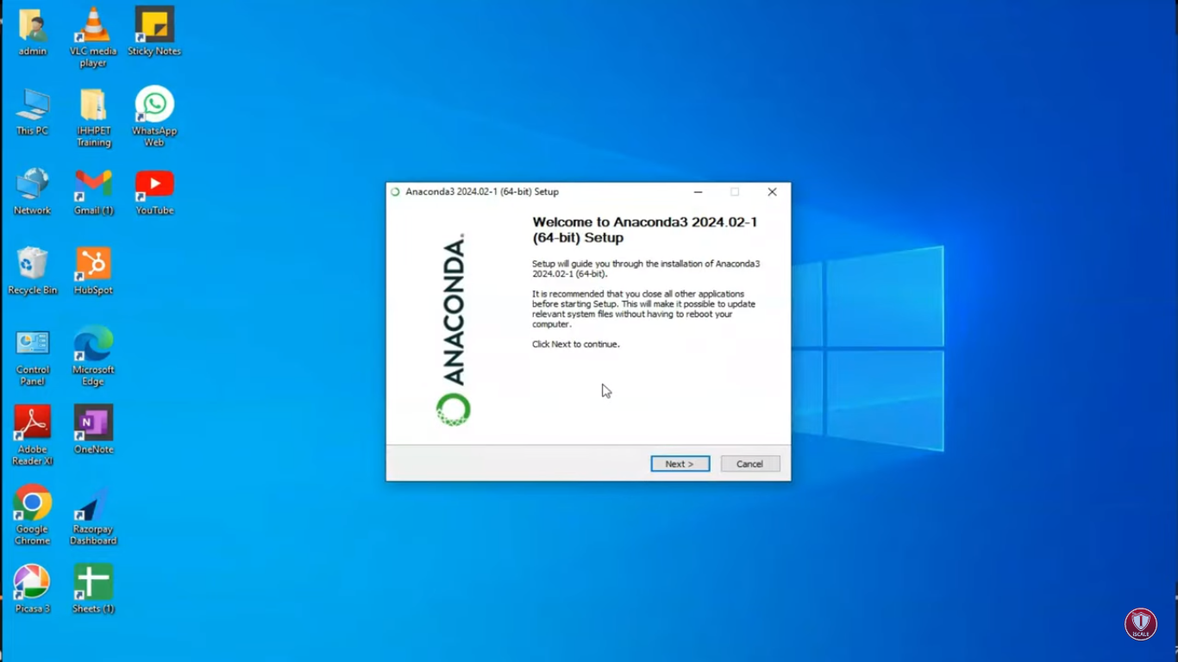

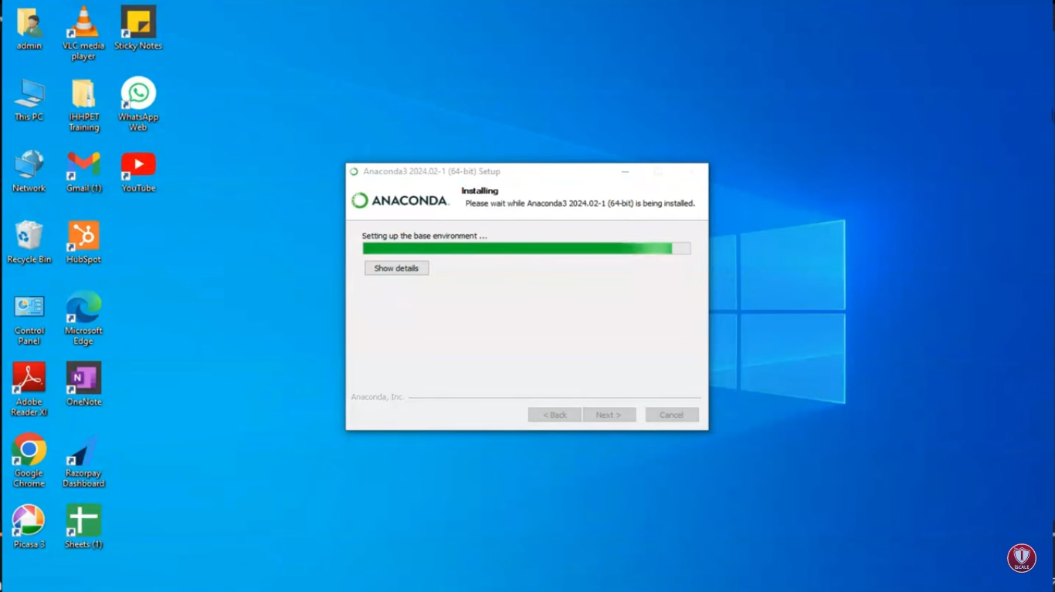



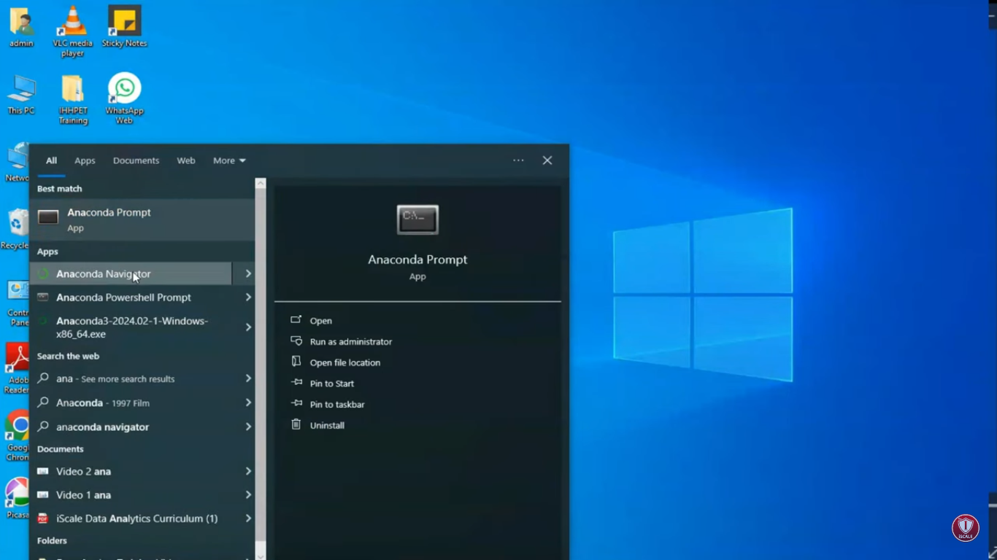

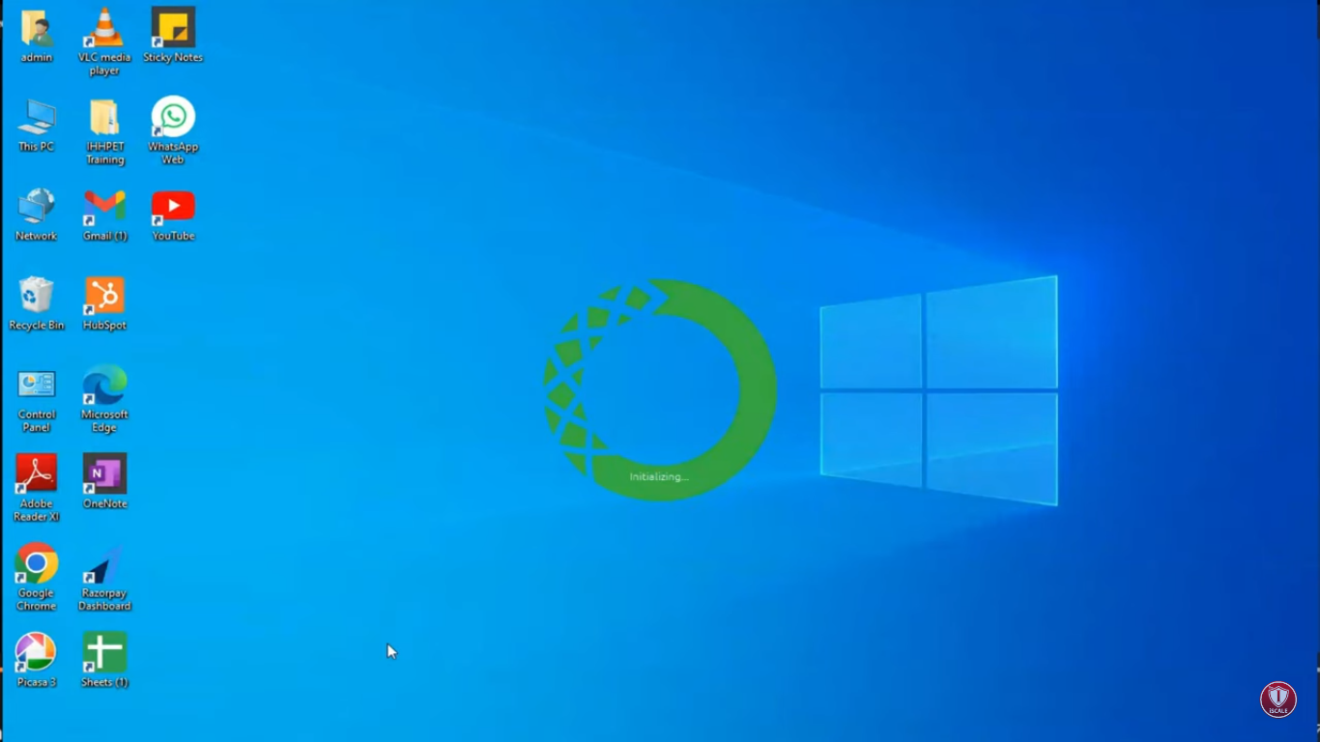

**Step 1: First,**Launch the Anaconda Navigator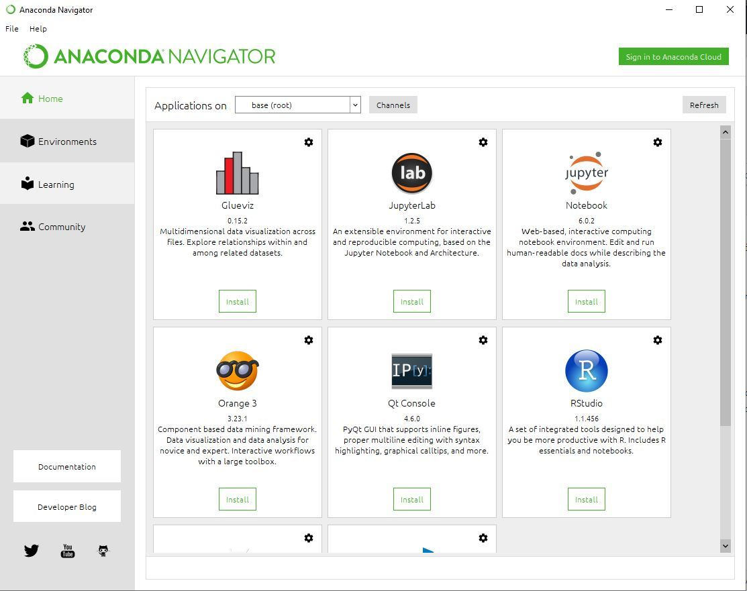

**Step 2:**Click on the Install Jupyter Notebook Button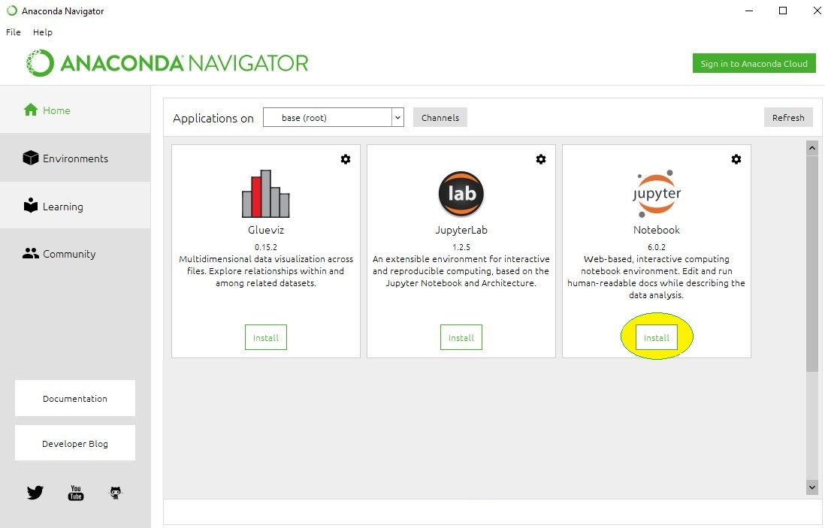The installation process is begin to Start!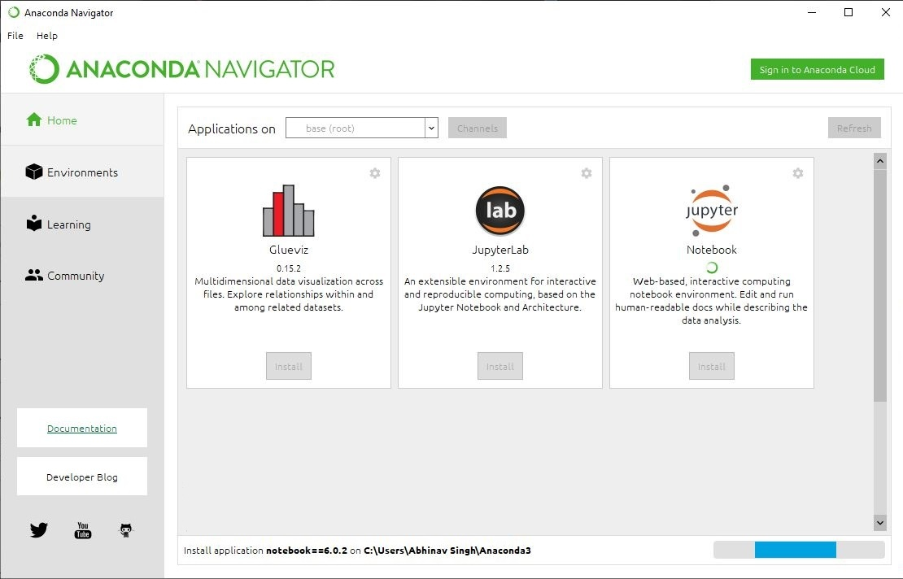

**Loading Packages:**

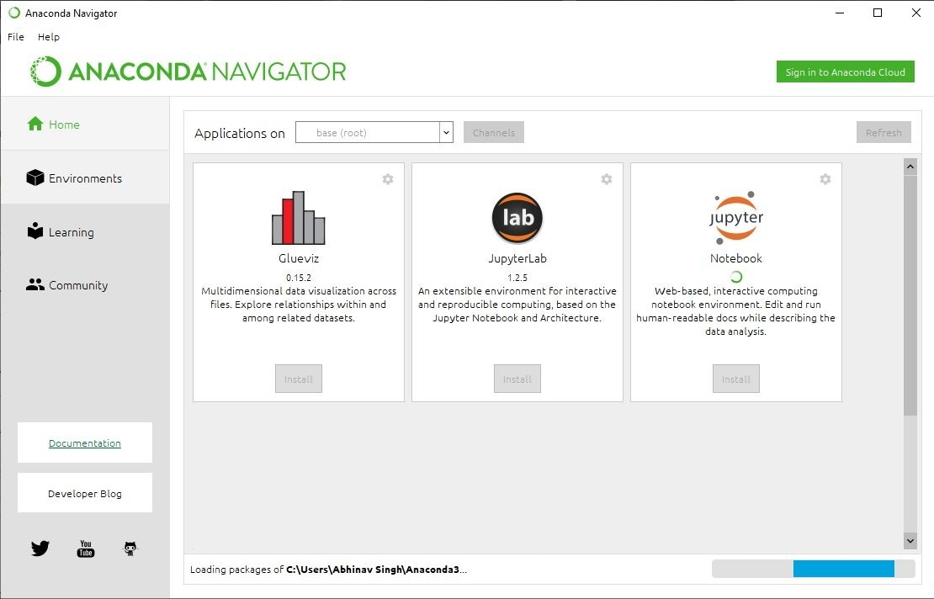

**Finished Installation:**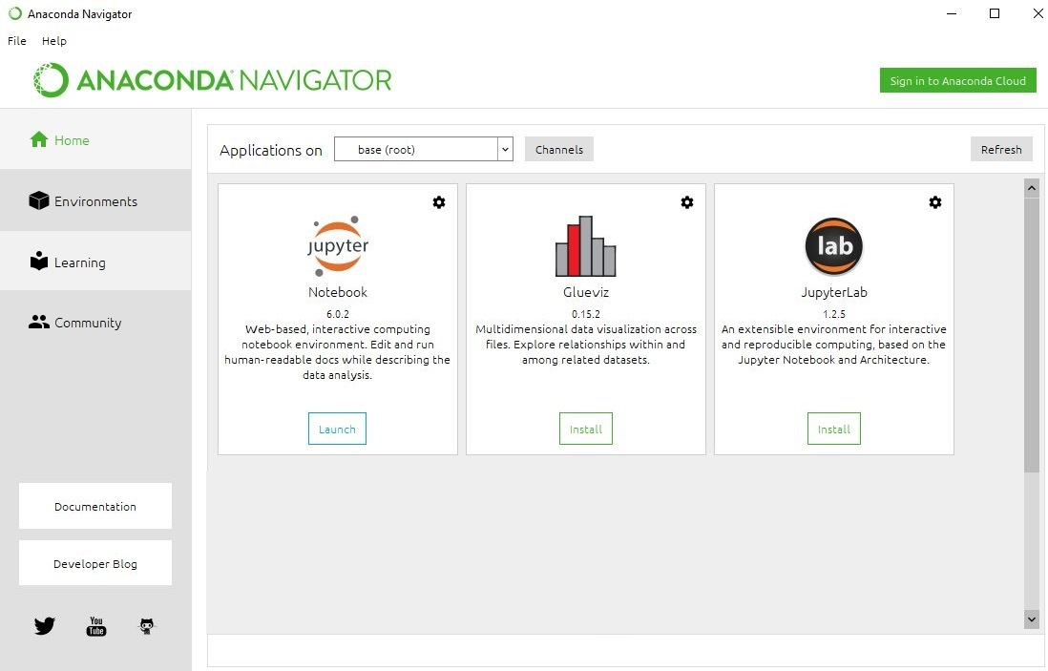

**Step 3:**Now, click on Launch button to Launch the Jupyter.

